
INNOVATION DAY, Casablanca, Friday, February 13, 2026
Sim2Win: A Team-Agnostic, Event-Based Pre-Match Tactical Recommendation System for Football.
By Mr. Mouad Zemzoumi
Supervisor: Dr. Amine Abouaomar
1. PROBLEM STATEMENT  Tactical decisions rely heavily on subjective intuition.  Existing models focus on outcome prediction, not tactical guidance.  Most systems depend on team identity or rankings.  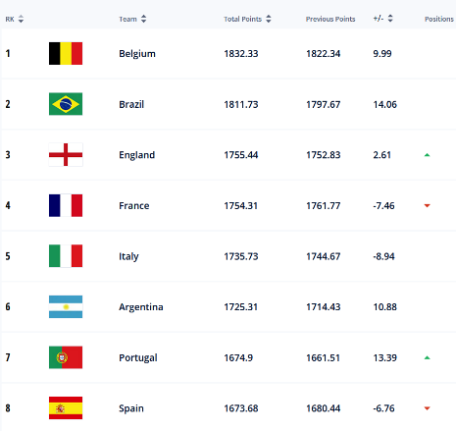 | 2. TARGET  MARKET  Football Analysts and Coaching Staff seeking opponent-specific strategies.  Sports analytics researchers and data science students. | 4. UNIQUE VALUE PROPOSITION  Team-Agnostic Generalization: Unlike other models, it does not rely on team names, results or rankings, allowing it to work for teams not present in the training data.  Actionable Recommendations: Reframes the problem from simple prediction to tactical recommendation, directly assisting decision-making.  Interpretability: Provides explainable insights based on event-based data rather than "black box" team ratings like Elo or Pi-Rating. | 5. Technology Stack  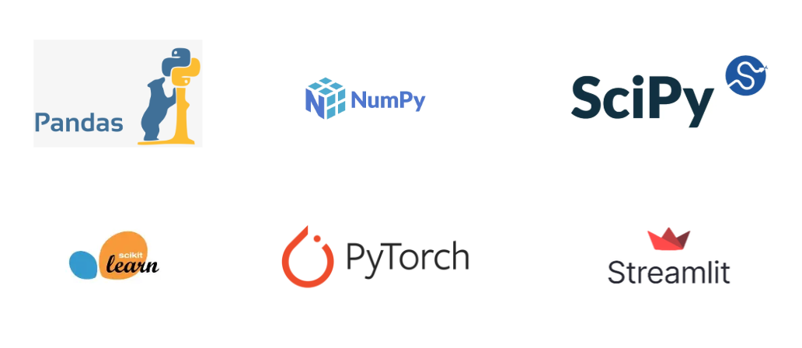 | 7. CHALLENGES AND RISKS  Noisy Recommendations: Tactical suggestions may contain statistical noise.  Data Sparsity: Potential difficulties in generating profiles for new teams with limited history.  Causal Interpretation: Risk of users misinterpreting correlations as direct causation.  Mitigation: Feature validation, Feature importance testing, and clear framing of the tool as a decision-support aid not a decision maker.
 | 3. SOLUTION OVERVIEW  Sim2Win is a system that analyzes based on historical data of a team its tactical configuration and estimates what is the best configuration to play against that team.  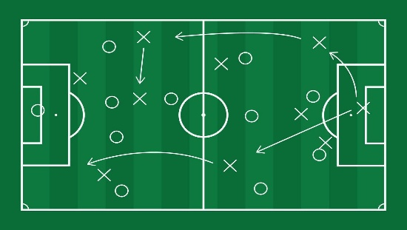 |  | 6. KEY ACTIVITIES  Data Processing: Aggregating multi-league data and cleaning it alongside feature engineering to create some features needed.  Modeling: Engineering tactical playstyle vectors and training probabilistic models linking tactics to outcomes.  Simulation Engine: Developing the mechanism to test various tactical configurations against specific opponents.  Validation: Evaluating performance using a "Tactical Agreement Score" on unseen teams.
8. REVENUE STREAMS  Licensing: Software licensing to professional football clubs and academies.  SaaS (Software as a Service) Model: Subscription access for freelance analysts and smaller coaching staffs.  Integration Fees: B2B (Business to Business) services for integrating the recommendation engine into existing sports data platforms. |  | 9. COST STRUCTURE  Development: Engineering time for coding, model tuning, and UI development.  Computational Resources: Cloud computing costs for training complex ML models on large datasets.  Data Acquisition: Costs associated with maintaining high-quality, event-based match data streams. |  | 10. IMPACT GOALS  Operational: Bridge the gap between predictive modeling and decision support.  Tactical: Assist coaching staff in preparing opponent-specific  Academic: Demonstrate that generalizable modeling is possible.

